### Automatic Fish Feeder

**Rationale**

An automatic fish feeder is a solid investment for any aquarium. It is an electrical or electronic gadget that is designed to dispense the accurate amount of food into the aquarium at a particular time each day. Some fish feeders can be set to feed the fish more than once a day. I come up in this project because it will help the Owner to lessen the work every day and sometimes the owner will forgot to feed their fish. Automatic fish feeders are either run on electricity through a power cord or batter operated. Fish feeders are usually clamped to the wall of the tank just over the water.

**Statement of the Problem**

Aquarist of the home based aquarium leads a busy life especially those who are away on vacation. So I come up this project because of the last exhibit the student are proposing a fish counting and It came up in my mind what if the owner are on vacation so decide today to propose this. They are often difficult to maintain a regular feeding schedule. However, the fish require regular care in order to remain healthy. If fish are not constantly fed small amounts at regular intervals, there can be significant loss of fish due to starvation. But, too much food in the water can easily clog up important filters, and cause you to have to spend more time cleaning your aquarium tank.

* Does the device help the owner to lessen the duties?
* Does the device can manage the time of feeding the fish?
* Does it help to the business?

**Features**

An automatic fish feeder can be attached to aquarium in many ways. It can be mounted on the aquarium, or on a compression tray, or on the glass edge of the aquarium with the help of brackets. This basically depends upon the make and type of the automatic fish feeder. Though there are many benefits of using an automatic fish feeder, some of the main benefits are regular feeding quantity, regular feeding time, desired number of feeds, and desired type of feeds. Hence, every fish gets its share of food at specific time without any problem and live happily.

**Schematic Diagram**

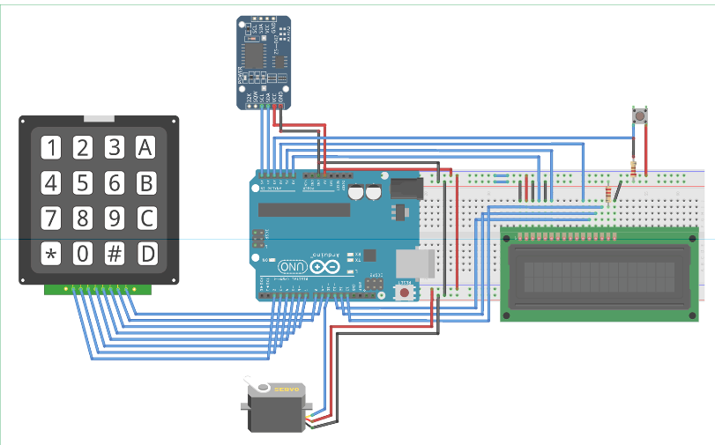

Material Required

* Arduino UNO
* 4*4 Matrix Keypad
* 16*2 LCD
* Push Button
* Servo Motor
* Resistor
* Connecting Wires
* Breadboard

**Block Diagram**

Power

Matrix Keypad

LCD

Arduino UNO

Servo Motor

**System Flow**

LCD display

Power On

KEYPAD

Set Timer

Process

Set already?

**Yes**

Output

Motor

**No**

Time already

Waiting for the time

**Water Quality Monitoring**

**Rationale:**

Water scarcity is the lack of sufficient available water resources to meet the demands of water usage within a region. **Water Quality Monitoring** is all about how to monitor the Quality of water, interns of monitoring the level of water, the temperature of the water and its surrounding, the turbidity of the water (how clean the water is) as well as the PH levels of the Water. It very useful to us because

**Statement of the Problem**

It is the difficulty of obtaining sources of fresh water for use during a period of time and may result in further depletion and deterioration of available water resources. Water shortages may be caused by climate change, such as altered weather patterns including droughts or floods, increased pollution, and increased human demand and overuse of water.

* Is there a device that can identified if the water is safe?

**Features:**

* Monitor temperature and Quality of water.
* Monitoring the level of water
* High quality, rugged sensors

**Schematic diagram**

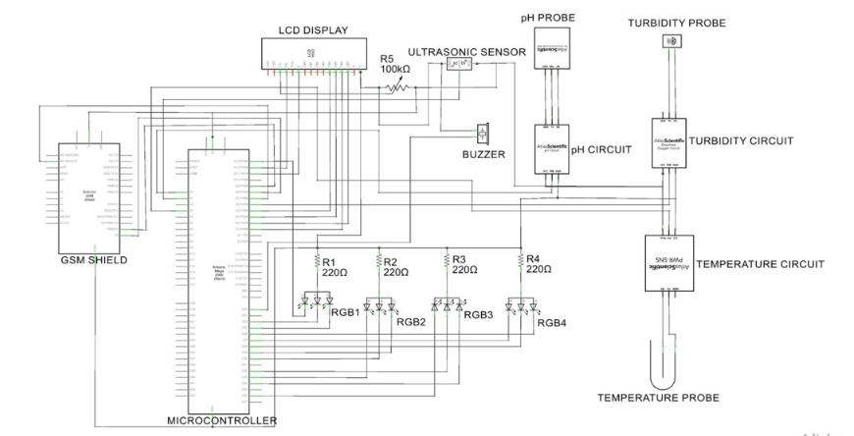

**Materials**

* Arduino Mega Board.
* (16 * 2) LCD display.
* The 2 in one Temperature and PH sensor.
* The Turrbidity Sensor.
* GSM shield.
* An ultrasonic Sensor.
* 4 RGB led.
* A buzzer.

**System Flow**

LCD Display

Ultrasonic Sensor

A Group of Water

Software

Output

**UNIVERSITY OF CEBU-MAIN CAMPUS**

**COMPUTER ENGINEERING DEPARTMENT**

Osmeña Boulevard Corner Sanciangko Street , Cebu City

DATE : July 3, 2019

TITLE : **Automatic Fish Feeder**

Approved

Disapproved

Comments/Suggestions:

___________________________________________________________________________________________________________________________________________________________________________________________________________________________________________________________________________________________________________________________________________________________________________________________________________________________________________________________________________________________________________________________________________________________________________________________________________________________________________________________________________________________________________________________________________________________________________________________________________________________________________________________________________________________________________________________________________________

**­**____________________________________________________________________________________________

**Evaluators:**

**_______________________________________**

**(Signature over printed name)**

**_______________________________________**

**(Signature over printed name)**

**_______________________________________**

**(Signature over printed name)**

**COMPUTER ENGINEERING DEPARTMENT**

Osmeña Boulevard Corner Sanciangko Street , Cebu City

DATE : July 3, 2019

TITLE : **Water Quality Monitoring**

Approved

Disapproved

Comments/Suggestions:

___________________________________________________________________________________________________________________________________________________________________________________________________________________________________________________________________________________________________________________________________________________________________________________________________________________________________________________________________________________________________________________________________________________________________________________________________________________________________________________________________________________________________________________________________________________________________________________________________________________________________________________________________________________________________________________________________________________

**­**____________________________________________________________________________________________

**Evaluators:**

**_______________________________________**

**(Signature over printed name)**

**_______________________________________**

**(Signature over printed name)**

**_______________________________________**

**(Signature over printed name)**

**Automatic Garbage Detection**

**Rationale:**

The Automatic Garbage Detection system is automatically detect and identified decoration garbage directly. The Automatic Garbage Detection will not going to open the garbage trash can if you will not put in the identification device. It helps to segregate the garbage well and it will lessen the work of the worker.

**Statement of the Problem**

There is lot of garbage that found everywhere that is not properly dispose to the trash can. One of the causes of this problem is the misbehavior of the people towards waste management. So this device will help the country clean.

**Feature**

* Identification a type of garbage.
* Automatic open the trash bin.

**Materials**

* Ultrasonic sensor
* Motor
* Raspberry pi
* Button
* LCD

**Block Diagram**

Sensor

Raspberry Pi

LCD

Servo motor

**Flow Chart**

Valid

Open the trash Bin/Output

Analyze the Object

Scanning the object

Power Button

**No**

**Yes**

**UNIVERSITY OF CEBU-MAIN CAMPUS**

**COMPUTER ENGINEERING DEPARTMENT**

Osmeña Boulevard Corner Sanciangko Street , Cebu City

DATE : July 3, 2019

TITLE : **Automatic Garbage Detection**

Approved

Disapproved

Comments/Suggestions:

___________________________________________________________________________________________________________________________________________________________________________________________________________________________________________________________________________________________________________________________________________________________________________________________________________________________________________________________________________________________________________________________________________________________________________________________________________________________________________________________________________________________________________________________________________________________________________________________________________________________________________________________________________________________________________________________________________________

**­**____________________________________________________________________________________________

**Evaluators:**

**_______________________________________**

**(Signature over printed name)**

**_______________________________________**

**(Signature over printed name)**

**_______________________________________**

**(Signature over printed name)**